**SQL Select Statements**

The data manipulation statements along with its English statement and results for the book recommendation database:

1. List user-ID such that it gives book rating < 5 and live in Baton Rouge, Louisiana, USA

select u.`User-Id`

from `BX-Users` u, `BX-Book-Ratings` r

where (u.`User-Id`=r.`User-Id`) and (r.`Book-Rating`< 5) and (u.`Location`='baton rouge, louisiana, usa');

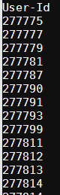

1. Get ISBN and average rate of books which published before 2000.

select `ISBN`, avg(`Book-Rating`) as avg_rate

from (select r.`ISBN`,r.`Book-Rating`

from `BX-Book-Ratings` r, `BX-Books` b

where (r.`ISBN`=b.`ISBN`) and (b.`Year-Of-Publication`< 2000)) as y

group by `ISBN`;

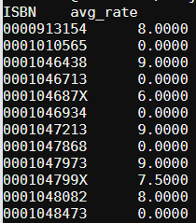

1. List user-ID such that the user’s age < 30 and gives average book rate < 5

select age.`User-ID`

from (select u.`User-ID`

from `BX-Users` u

where `Age` < 30) as age

inner join (select r.`User-ID`, avg(r.`Book-Rating`)

from `BX-Book-Ratings` r

group by r.`User-ID`

having avg(r.`Book-Rating`) < 5 ) as rate

on age.`User-ID`=rate.`User-ID`;

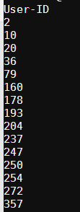

1. Get average rate of books which written by male author

select avg(`Book-Rating`)

from (select r.`Book-Rating`,r.`ISBN`

from `BX-Book-Ratings` r, `BX-Authors` a, `BX-Books` b

where (r.`ISBN`=b.`ISBN`) and (b.`Book-Author`=a.`Name`) and (a.`Gender`='Male')) as y

group by `ISBN`;

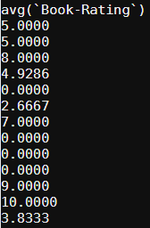

1. Get number of books written by female author which published before 2000

select count(`ISBN`)

from `BX-Books` b, `BX-Authors` a

where (b.`Book-Author`=a.`Name`) and (a.`Gender`='Female') and (b.`Year-Of-Publication`<2000);

C:\Users\jliu96\Desktop\select5.png

1. List book title and publisher whose average rating > 5

select b.`Book-Title`,b.`Publisher`

from `BX-Books` b,`BX-Book-Ratings` r

where (b.`ISBN`=r.`ISBN`)

group by r.`ISBN`

having avg(r.`Book-Rating`)>5

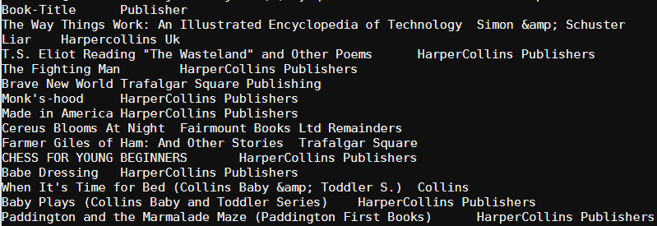

1. List average rate of user in Baton Rouge, Louisiana, USA

select avg(r.`Book-Rating`)

from `BX-Book-Ratings` r, `BX-Users` u

where (u.`User-ID`=r.`User-ID`) and (u.`Location`='baton rouge, louisiana, usa')

group by r.`User-ID`;

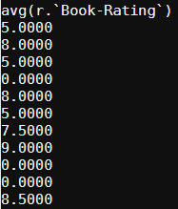

1. List number of books written by female author

select count(b.`ISBN`)

from `BX-Books` b, `BX-Authors` a

where (b.`Book-Author`=a.`Name`) and (a.`Gender`='Female');

C:\Users\jliu96\Desktop\select8.png

1. Get maximum rate of books published by each publisher

select max(avg_rate),`Publisher`

from (select avg(r.`Book-Rating`) as avg_rate, b.`Publisher`

from `BX-Book-Ratings` r, `BX-Books` b

where (b.`ISBN`=r.`ISBN`)

group by r.`ISBN`) as y

group by `Publisher`;

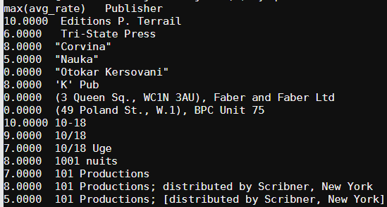

1. List all ISBN and Book-Author of books rated by user living in Baton Rouge, Louisiana, USA.

select distinct b.`ISBN`,b.`Book-Author`

from `BX-Books` b, `BX-Book-Ratings` r, `BX-Users` u

where (b.`ISBN`=r.`ISBN`) and (r.`User-ID`=u.`User-ID`) and (u.`Location`='baton rouge, louisiana, usa');

